
Locations

Main Office – Dennison
Gnadenhutten Office
130 North Walnut Street
Gnadenhutten, Ohio 44629
Phone: 740.254.4321
Fax: 740.254.9322

Schoenbrunn Office
Loan Processing Center
2046 East High Avenue
New Philadelphia, Ohio 44663
Phone: 330.339.3789
Fax: 330.339.0639
105 Grant Street
Dennison, Ohio 44621
Phone: 740.922.2532
Fax: 740.922.2051

Dover Office
824 Boulevard
Dover, Ohio 44622
Phone: 330.364.8671
Fax: 330.364.3611

Southside Office
706 South Broadway
New Philadelphia, Ohio 44663
Phone: 330.339.1150
Fax: 330.308.5949

ATM’s Available at all Locations 24/7
ITM’s Available at the Southside Office and the Schoenbrunn Office

Hours of Operation
(The Schoenbrunn lobby and drive thru is not open to the public)
 | Drive Thru | Lobby
Monday | 8:00am - 5:00pm | 9:00am - 5:00pm
Tuesday | 8:00am - 5:00pm | 9:00am - 5:00pm
Wednesday | 8:00am - 12:00pm | 9:00am - 12:00pm
Thursday | 8:00am - 5:00pm | 9:00am - 5:00pm
Friday | 8:00am - 5:30pm | 9:00am - 5:30pm
Saturday | 8:00am -12:00pm | 9:00am -12:00pm
Sunday | Closed | Closed

Dennison Office
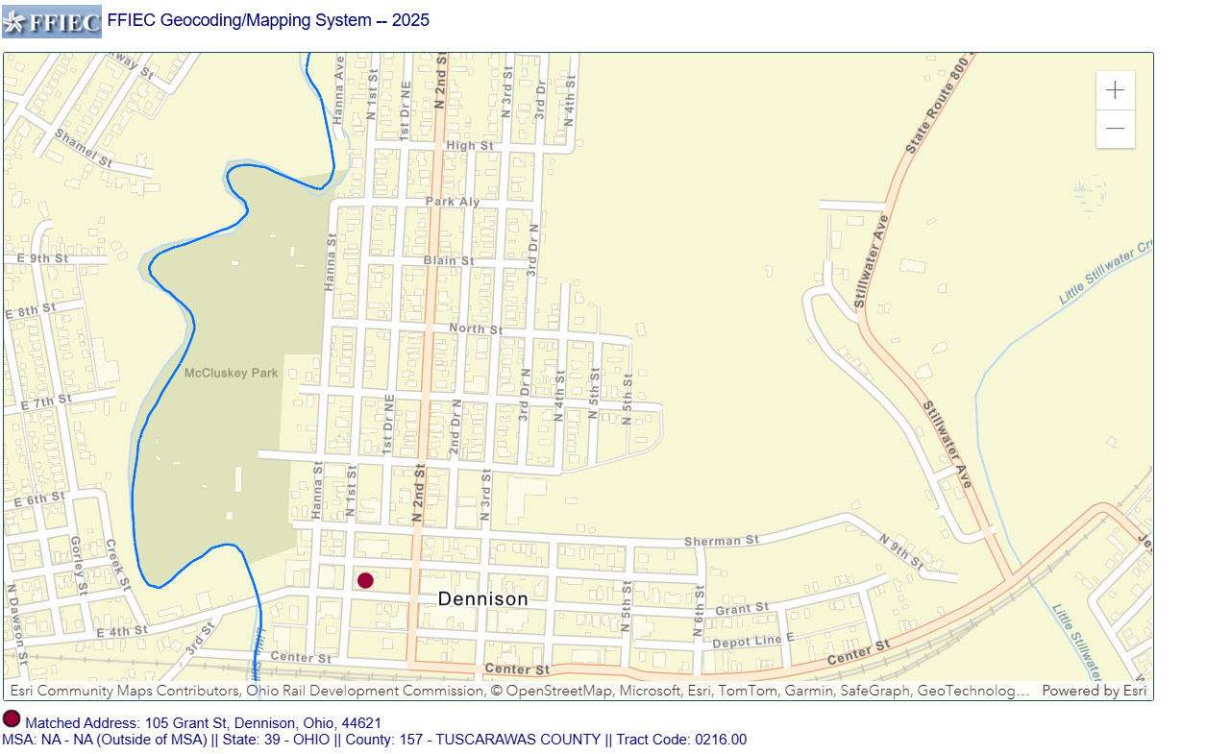
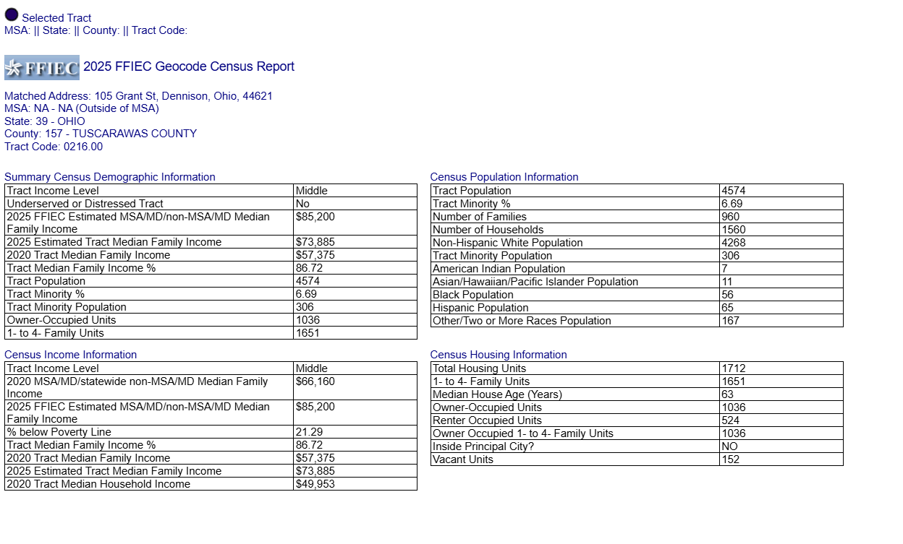

Dover Office
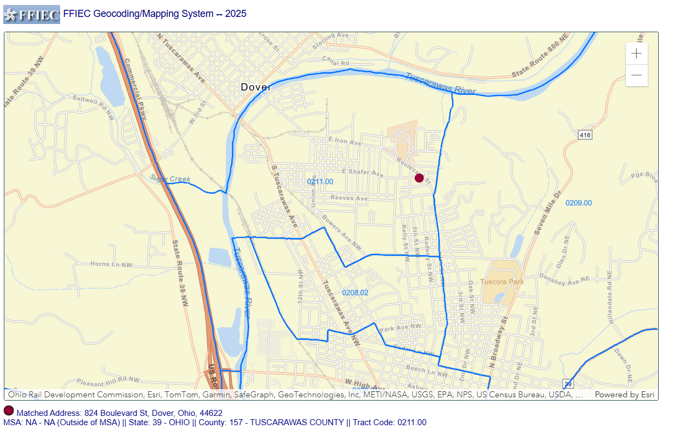
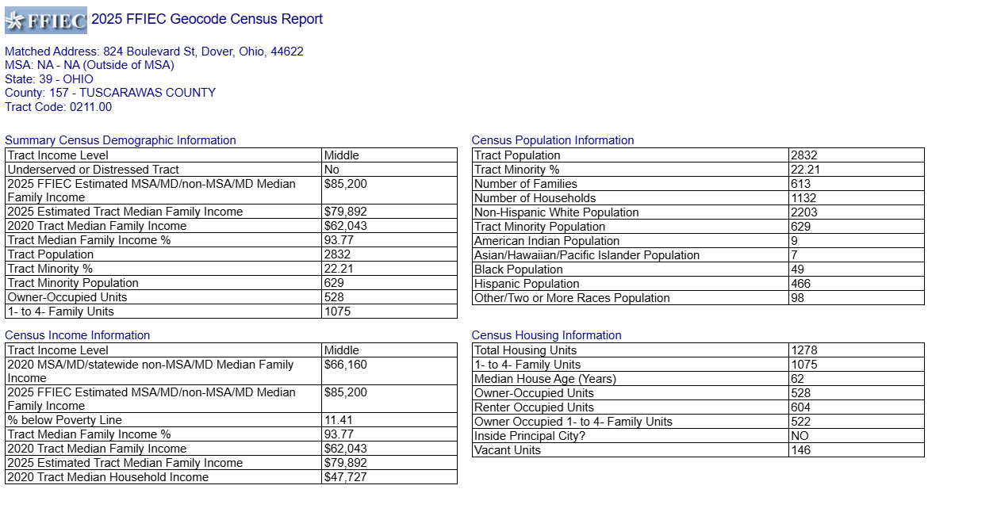

Southside Office
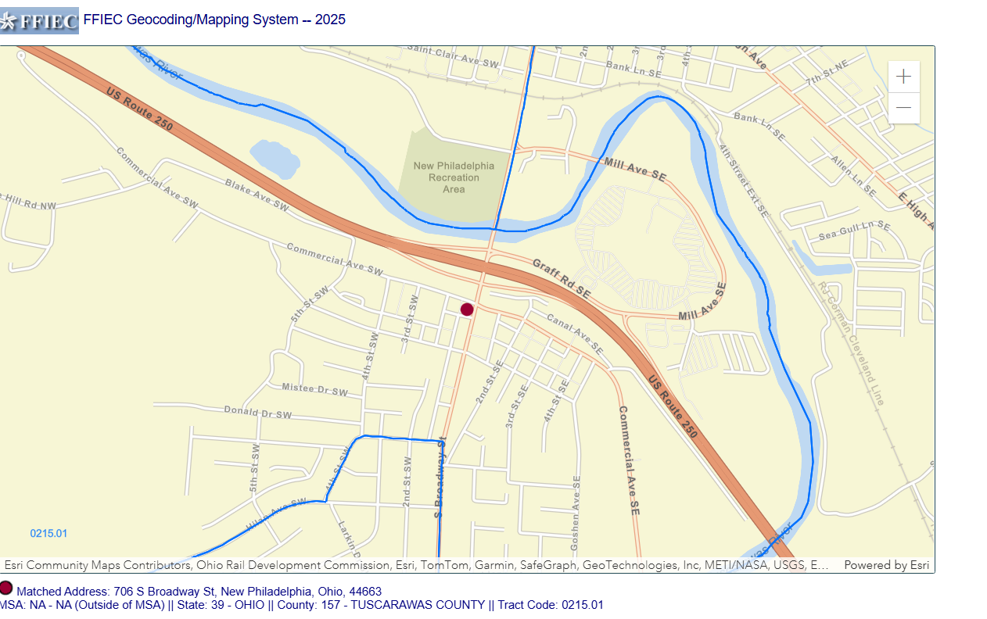
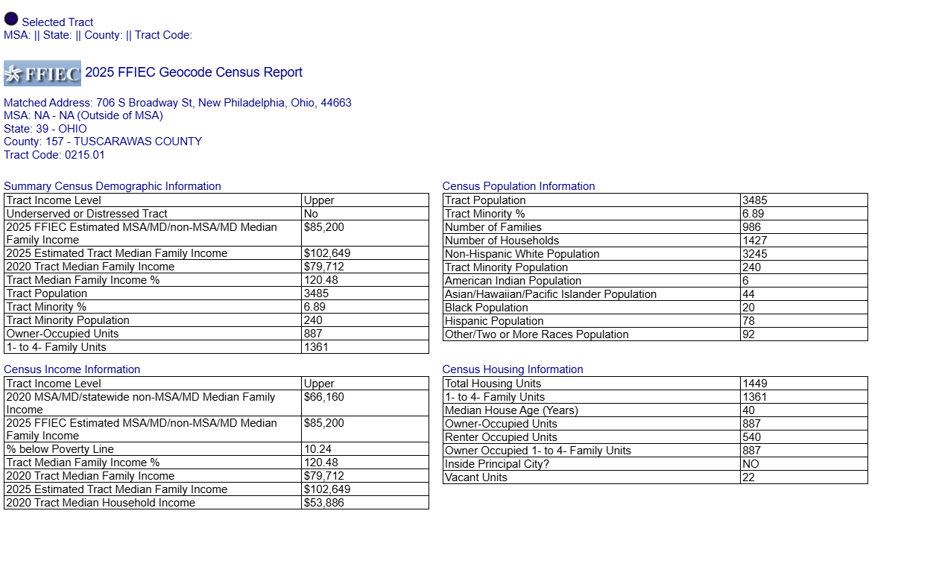

Gnadenhutten Office
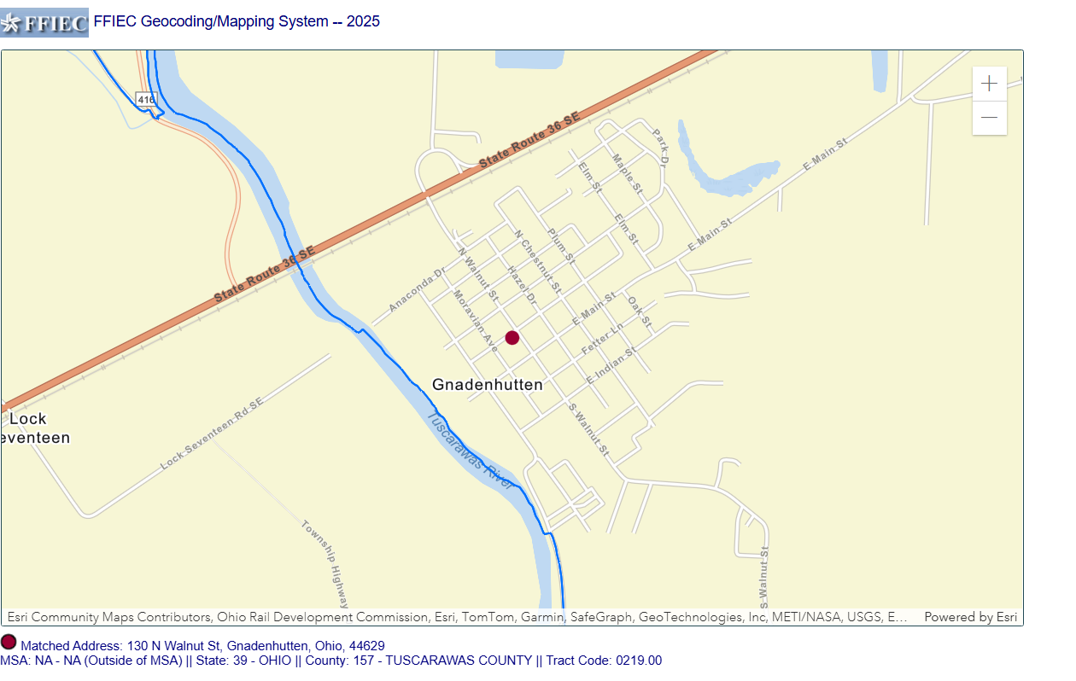
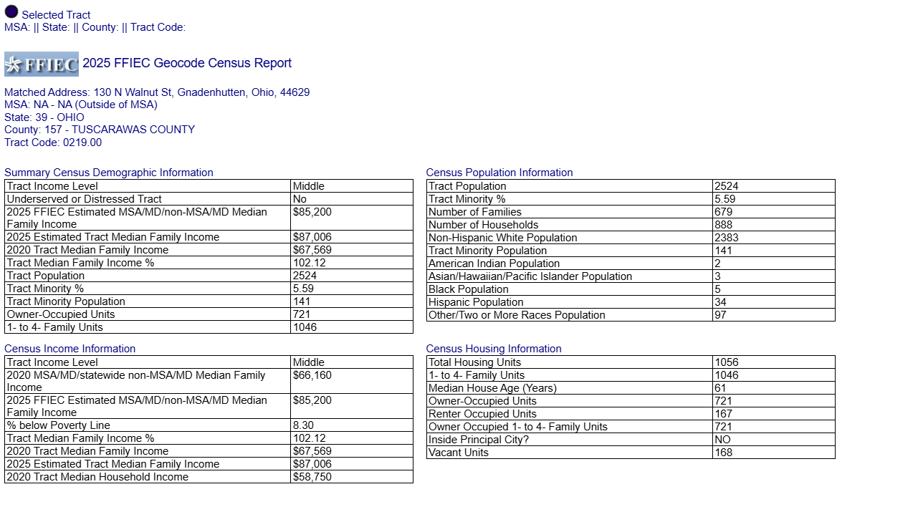

Schoenbrunn Office
Loan Processing Center
